 

INSTITUTE FOR ADVANCED COMPUTING AND SOFTWARE DEVELOPMENT AKURDI, PUNE

Documentation On

“Rent-A-Style”

Ecommerce Store for Renting Clothes

PG-DAC SEPT 2022

**Submitted By:**

**Group No: 05**

**Roll No. Name:**

**229005 Aman Agham**

**229012 Anvesh Modak**

**Mr. Sonali Mogal Mrs. Rohit Puranik**

**Project Guide Centre Coordinator**

ACKNOWLEDGEMENT

This project was a great learning experience for us and we are submitting this work to Institute for Advance Computing and Software Development (C-DAC IACSD, Akurdi). I extend my sincere and heartfelt thanks to our esteemed guide, **Mrs. Sonali Mogal** for providing me with the right guidance and advice at the crucial juncture sand for showing me the right way. I extend my sincere thanks to our respected **Centre Co-Ordinator Mr. Rohit Puranik**, who gave us all the required support and kind coordination to provide all the necessities to complete the project and allowing us to use the facilities available throughout the course. I would like to express our sincere gratitude towards Mrs. Madhura Anturkar and Mrs. Kishori Khadilkar, our faculty for J2EE and React, who was always there for us. Their guidance and support helped us overcome various obstacles. Without their tremendous support, guidance, and efforts, this project would not have been possible. I would like to thank the other faculty members also, at this occasion. Last but not the least, I would like to thank my friends and family for the support and encouragement they have given me during the course of our work.

From:

|  |  |
| --- | --- |
| Aman Agham  Anvesh Modak | 220941220008  220941220021 |

TABLE OF CONTENTS

ABSTRACT

1. INTRODUCTION
2. PRODUCT OVERVIEW AND SUMMARY
   1. Purpose
   2. Scope
   3. Overview
   4. Feasibility Study
3. REQUIREMENTS FULFILLED
   1. Functional Requirements
   2. Non-Functional Requirements
4. PROJECT DESIGN
   1. Data Model
   2. Use Case Diagram
   3. DFD Diagram
   4. Activity Diagram
   5. ER Diagram
   6. Class Diagram
5. PROJECT SCREENSHOT
   1. Customer
   2. Admin
6. TESTING
7. CONCLUSION
8. FUTURE SCOPE
9. REFERENCES

ABSTRACT

The growing popularity of online clothing rentals is fueled by the desire to keep up with the latest trends. Buyers all over the world know the product. Customers now prefer the purchase of online clothing due to easy access and the availability of great options at a low price, due to the increase in internet penetration. This also exacerbates the global demand for online rental clothing. The online clothing rental market is expected to grow due to lifestyle changes and popularity of party dresses, designer dresses, and dinner suits. Therefore, product rental will be considered the most sustainable way to use clothing today, as industries use sustainability as their key business plan to attract more customers. Excessive use and indiscriminate disposal of unwanted clothing has become a global problem and many of these items are discarded without purpose. This, in turn, demonstrates the potential for profit for players in the global clothing rental market.

The web-based app is an renting system for clothing product where seller can add product which can be rented. It helps renting of the products through internet by using a website device. Thus, the customer will get the service of browsing and getting clothes on rent without investing much money and not worrying about wardrobe stacking. Since this application is available in the Smartphone it is easily accessible and always available

1. INTRODUCTION

Whenever we need something that we don’t have, we go to a store and purchase it. But sometimes, even in the store those items are not available. So we go to a mall to get everything we need, all at once. It’s a one stop destination. But what if we can bring the whole mall at your own house? One can do all the shopping they need to, and can check thousands of products without even stepping outside their house. That is the idea which gave birth to the concept of online shopping.

Not only you can get exactly what you want when you shop online, you can also try to get a better deal by browsing across some other online stores. This project “E- Store” is an effort to cater the people by providing them with products of various varieties. From your daily need things to thing you need for your home, all in one place.

From a customer’s point of view, they can browse through a catalogue

of products, search for products, add products to their cart and place orders. Customers can even create an account and add addresses. They can easily browse products via category feature. Register their account login to their account, update their account, delete their account

From the admin’s point of view, the admin can view seller details, customer details, order details and can also delete customer and seller accounts if needed. Register their account login to their account, update their account, delete their account. From the seller’s point of view, they can add a product, update the product, new sellers can register their account, login to their account, update their account details and delete their account.

2. PRODUCT OVERVIEW AND SUMMARY

2.1. PURPOSE

Our project, “Rent-A-Style”, is a web-based online e-commerce website which aims to provide users with an easy to navigate and visually appealing medium to browse through a catalogue of products and shop

for the products they desire.

2.2. SCOPE

“Rent-A-Style” aims to deliver a web-based application that hosts a wide collection of products that users can browse through. Users can add products to cart and place orders for each product. They can update their profile, add delivery address and add payment details.

They can view their current order as well. Seller can manage various product details like price, adding new products, updating existing products etc.

This project does not support the actual logistics and delivery of product and actual payment logic. We are assuming that the organization that implements it will be using third-party payment API which can easily be integrated in our application if needed.

Rent-A-Style is only an interface for both customers (for browsing and shopping for products) and sellers (for managing products).

2.3. OVERVIEW

1. TECHNOLOGIES USED

* FRONT END
  1. Bootstrap
  2. React
* BACK END
  1. Spring Boot
* DATABASE MANAGEMENT SYSTEM

1. MySQL
2. FEATURES PROVIDED

* FOR CUSTOMERS

1. Browse – Customers can browse the homepage to explore the entire collection of products available.
2. View– When a customer checks product details, they can also view the details.
3. Register, Login & Logout – New customers can register on the site. Existing customers can then login to access their account information and logout when the account is not in use.
4. View & Update Profile – When logged in, customers can view their profile and update their details.
5. Add to Cart & Place Orders – If customers find products that they like, they can save the products in the cart until they decide to purchase it. When they wish to purchase it, they can place orders for those products by selecting a delivery address.
6. View Order Details – Every customer can view their order history in order to get an idea about their past spendings and how much they saved on each order.

* FOR SELLER

1. Register, Login & Logout – Similar to customers, sellers can register their account, login & logout to access their account.
2. Delete Product –The seller can delete a product if they need to for any purpose.
3. Add New products –seller can add new products with all the necessary details like product name, brand, category, price, etc.
4. Update product Details – Often, the details of a product such as the price, may change over time. In such cases, the seller can update those product details to reflect the change on the application.

* FOR ADMIN

1. Login & Logout – Similarly admin can login & logout to access their account.
2. Delete customer and seller – The admin can delete a customer or seller if they need to for any purpose.
3. Admin can also view order history.
4. Admin can also update details like password

2.4. FEASIBILITY STUDY

Feasibility is the determination of whether a project is worth undertaking or not. Before actually recommending the new system, it is important to investigate if it is feasible to develop it. Before developing and implementing a system, we have to make sure that the system is feasible in the following ways:

1. TECHNICAL FEASIBILITY

In this type of feasibility study, the system analyst has to check whether it is possible or not to develop the requested system with the available manpower, software, hardware, etc. This project makes use of cross-platform software and solutions like Java, and hence can run on any operating system. React, used in front-end, is swift and light weight framework when it comes to delivering the requested page as it doesn’t reload the entire page for every HTTP request. It only re-renders the components that need to fetch new data. Also, as React is modular in nature, it is easy to develop new components and scale up existing components in order to add new features to the system.

The combination of Spring Boot for backend makes for a fast, easy to set-up and reliable system to interact with the database, as they are secure and transactional in nature. Since the sensitive data of customers and admins need to be stored in a robust and secure database, MySQL database management system was chosen as it is an industry standard.

1. OPERATIONAL FEASIBILITY

In this type of feasibility study, the operation of the system is considered. An analysis is performed on whether it is feasible for the user department to use the application. Thus, the proposed system is said to be operationally feasible only if clients are able to understand the system clearly and correctly, and can use it with ease.

In the design of this project, we always kept user experience in mind. We made an effort to have a good user interface with consistent theme and alluring design to keep the users interested and engaged.

In our project, the use of universally known icons and instructions that are easy to understand makes sure that the user will not need any special technical know-how to use the application. We made sure that the information available throughout the application is arranged in a logically coherent and consistent manner, guaranteeing that the users will have a smooth and effortless experience and even enjoy using the application.

C.ECONOMIC FEASIBILITY

In this type of feasibility study, the benefits of the system to the organization are considered by taking into consideration the cost-benefit analysis. All the software and technologies used in our project free, open-source, and widely available, with each of the technologies having an extensive community support. This makes “Rent-A-Style” an economically feasible solution to the organizations that wish to implement it.

3.REQUIREMENTS FULFILLED

3.1 FUNCTIONAL REQUIREMENTS

Following are the functional requirements fulfilled by our project:

* Customers can browse through all available products.
* Customers can place orders for products and view their order history.
* Sellers can manage various product details like product price, adding new products, etc.
* Sellers can update the product details.
* Sellers can update their account details and delete their account if needed.
* Admins can delete customers and sellers if the need arises.
* Admins can view all the orders placed by the customers.

3.2 NON-FUNCTIONAL REQUIREMENTS

Following are the non-functional requirements fulfilled by our project:

* Since the application uses lightweight and established software components that are also cross-platform, it is remarkably performant and has good support for every operating system.
* The use of React for front end and Spring Boot for back end delivers quick response times to admins and customers alike.
* Card-style UI and well-known icons and symbols used throughout the application provides a consistent theme and user-friendly interface that anyone can grasp easily, even without a technical background.

4. PROJECT DESIGN

4.1.DATA MODEL

The following tables depict the database design used for “Rent-A-Style” application:

* Tables Related to User Details

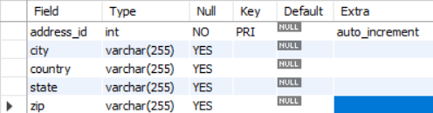

* + 1. Addresses Table 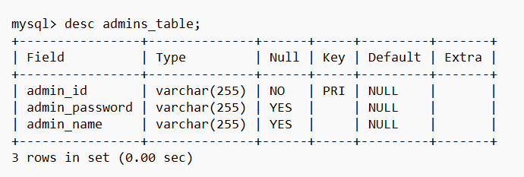
    2. Admin Table 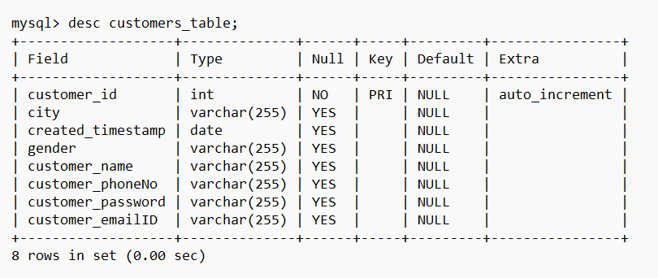
    3. Customers Table

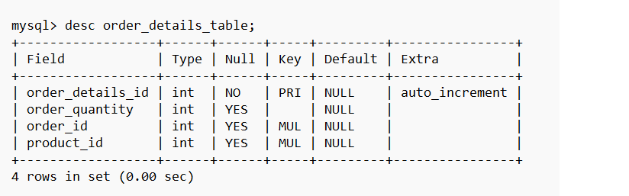

* + 1. Order Details Table

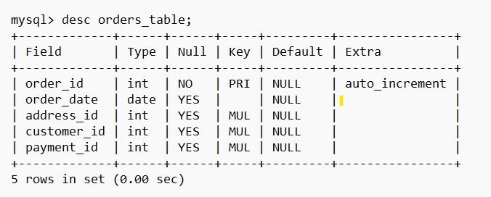

* + 1. Orders Table 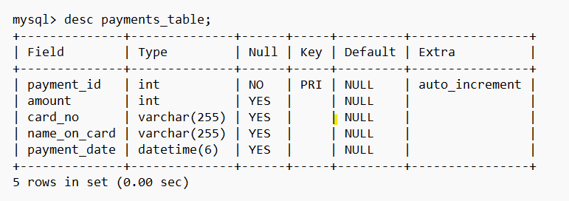
    2. Payments Table 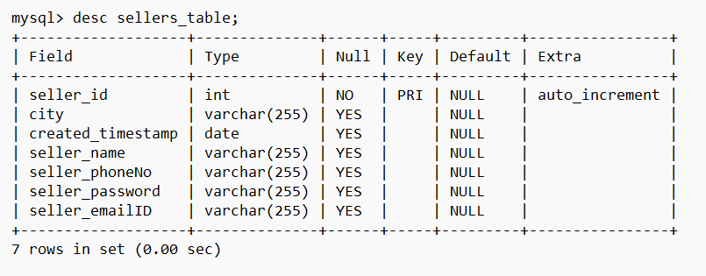
    3. Seller Table 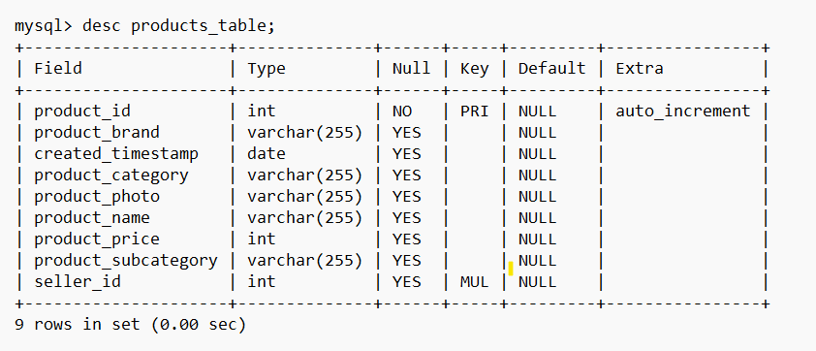
    4. Products Table

4.2.USE CASE DIAGRAM

A. Customer

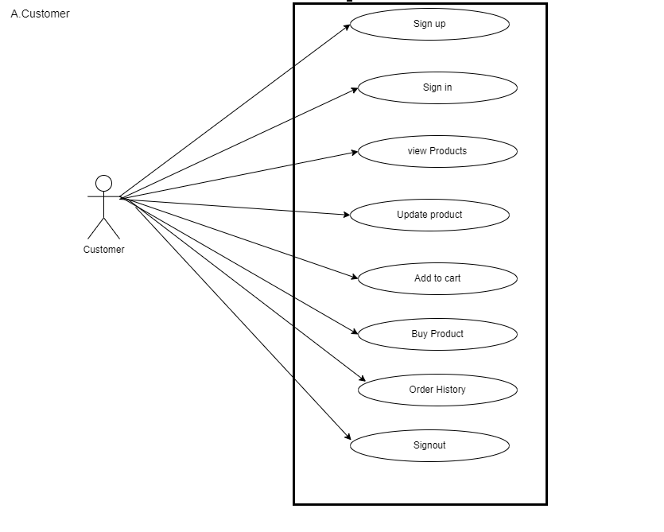

1. Admin

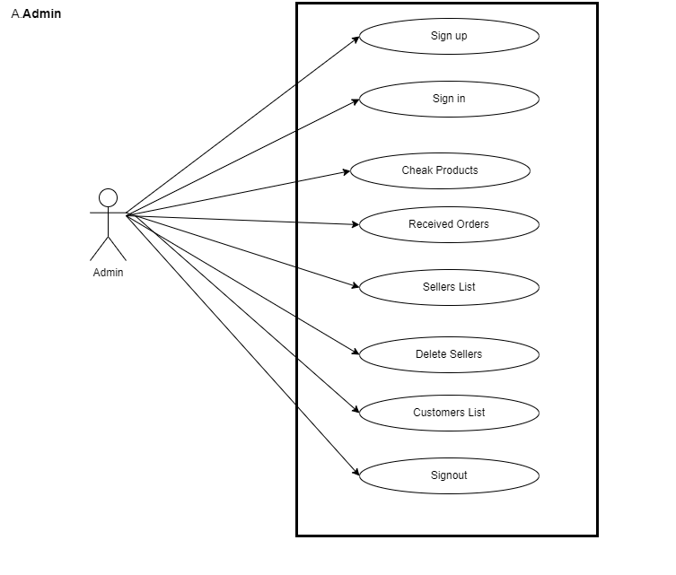

C.SELLER

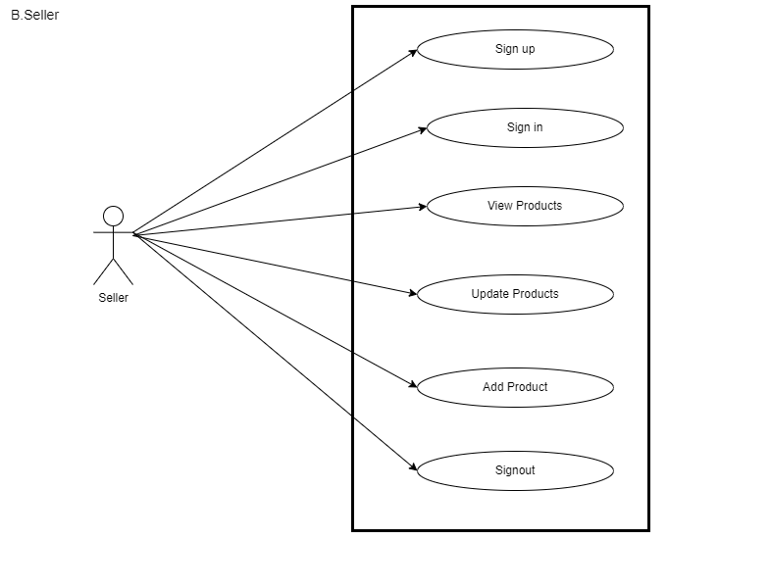

4.3. DFD DIAGRAM

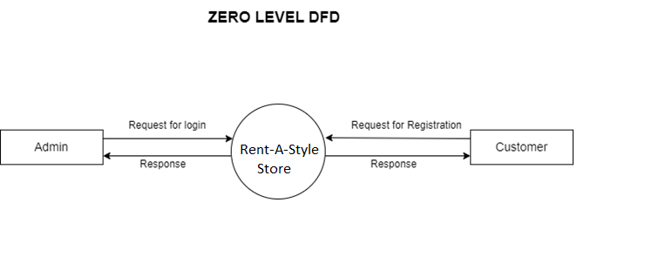

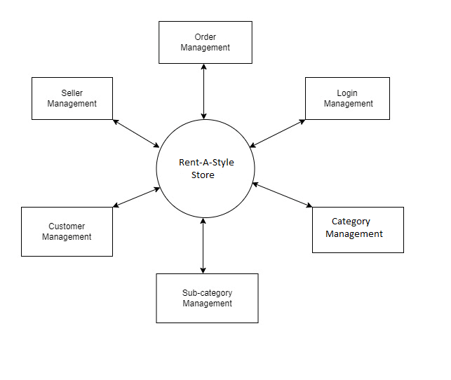

4.4.ACTIVITY DIAGRAM

A. Customer

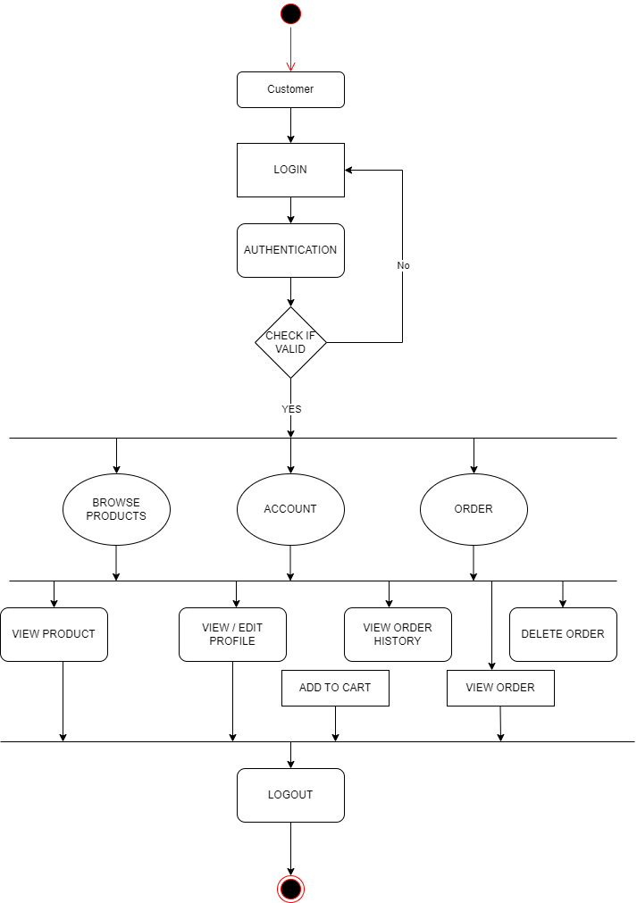

1. Admin

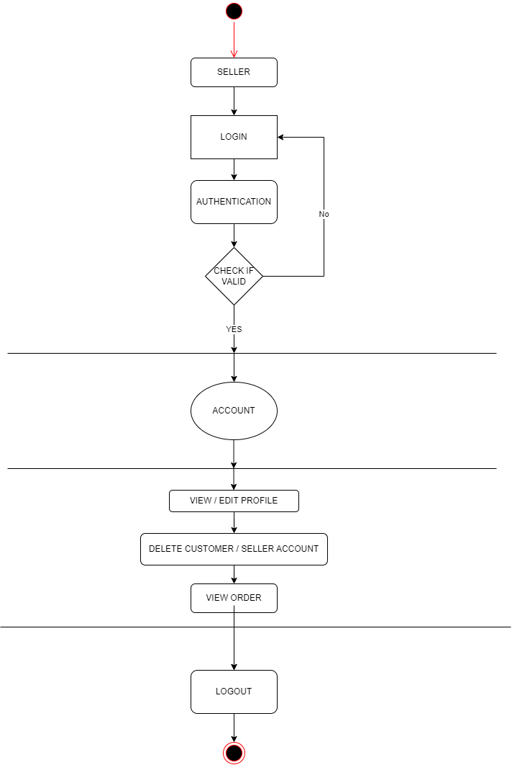

C.SELLER

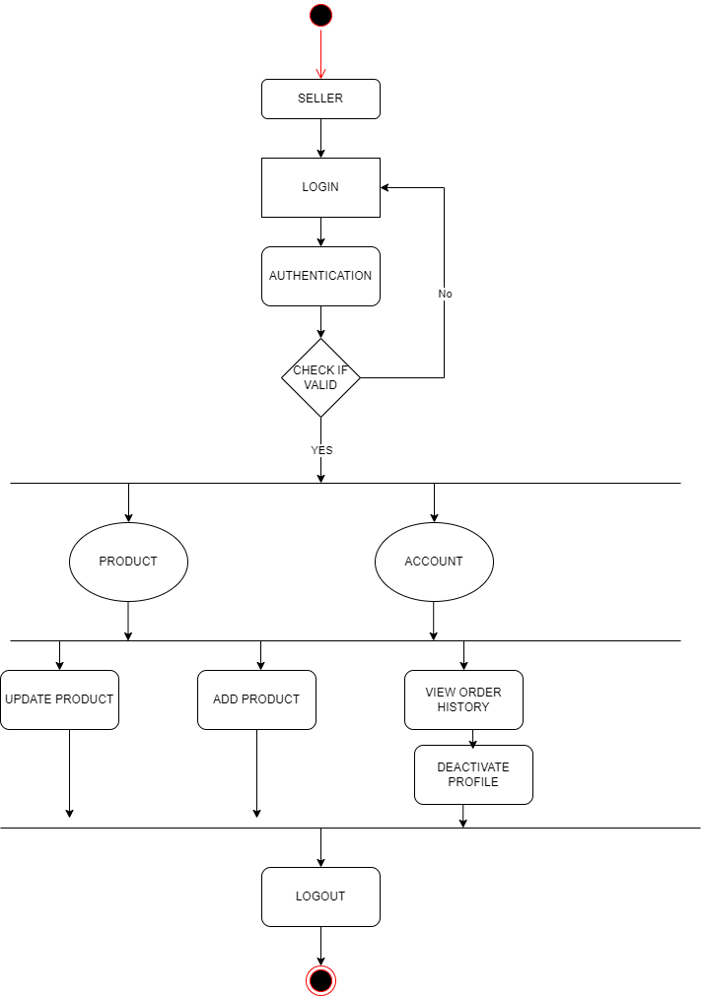

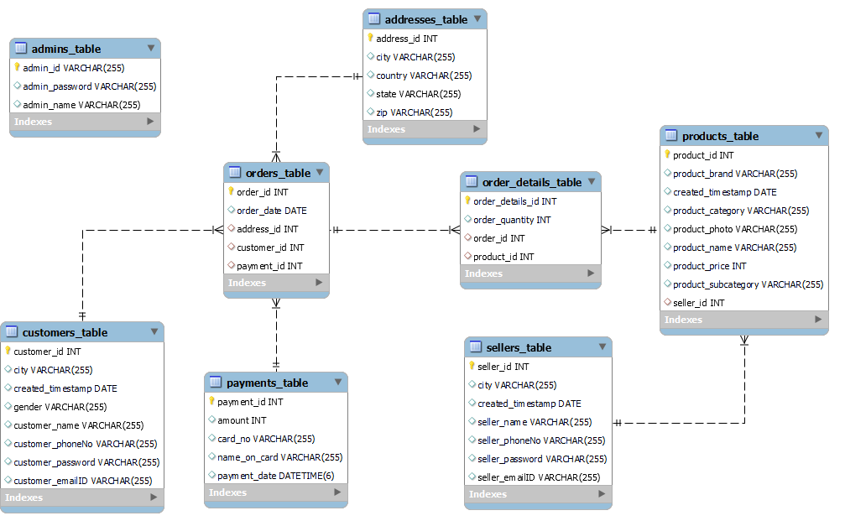4.5.ER DIAGRAM

System Generated

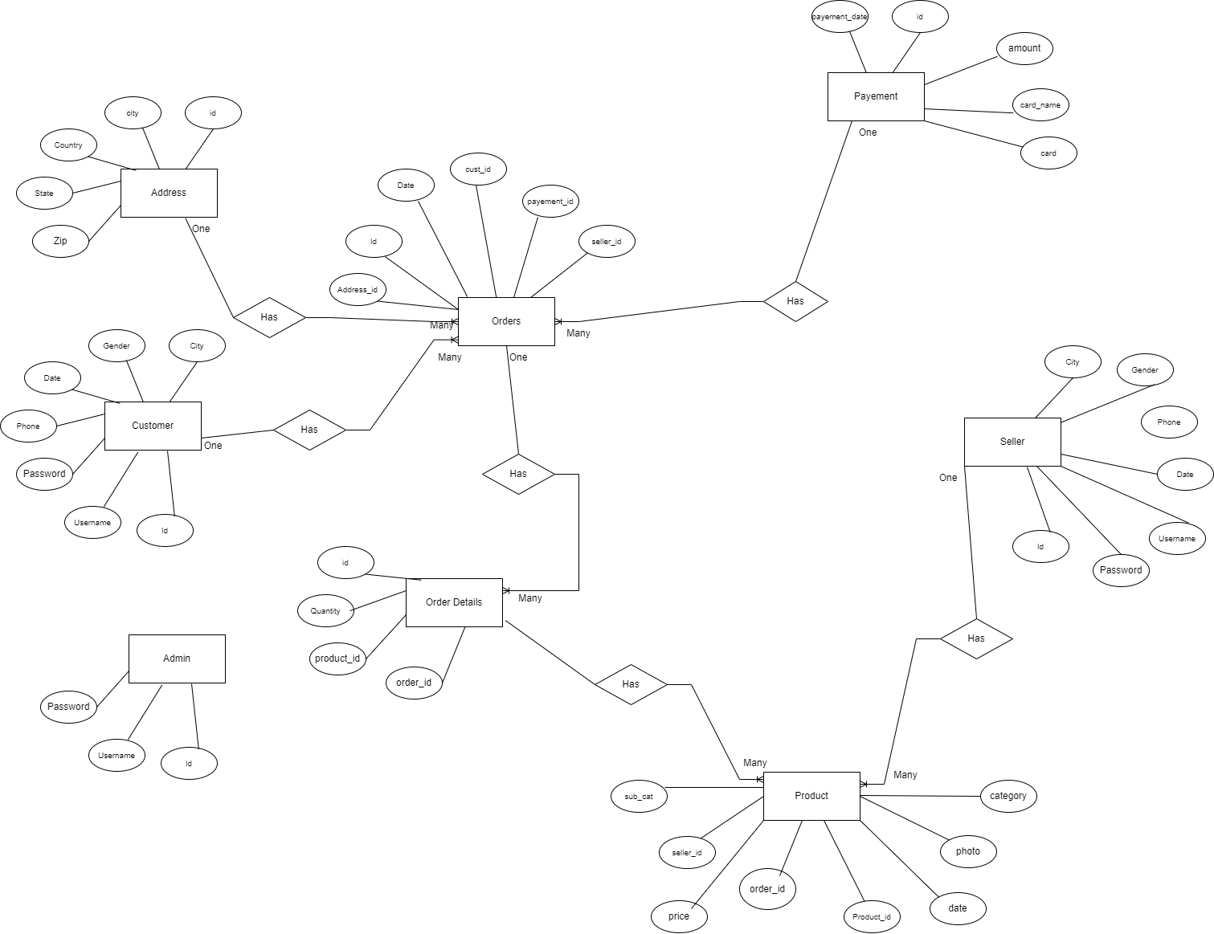

Manual

4.6.CLASS DIAGRAM

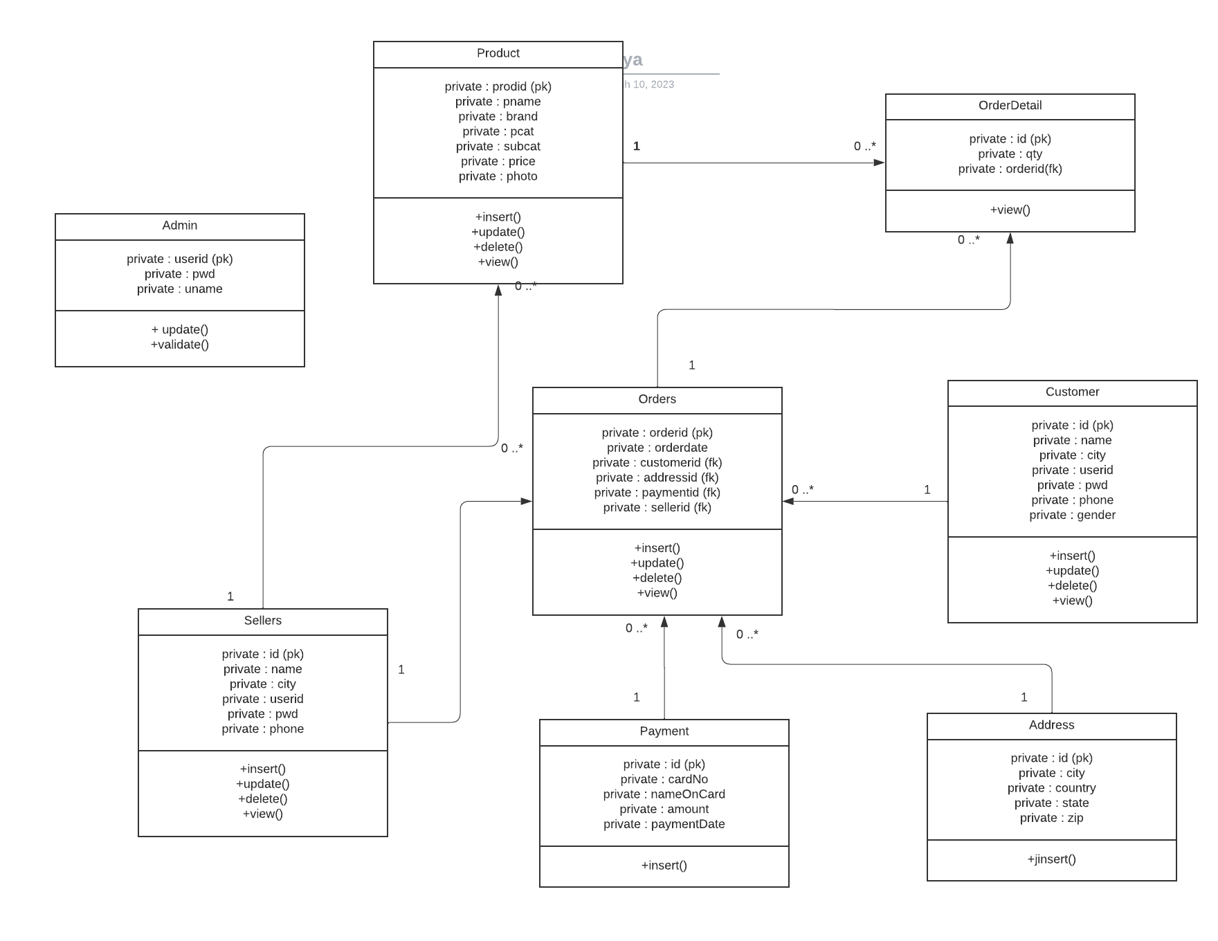

5. PROJECT SCREENSHOTS

5.1.CUSTOMER

* 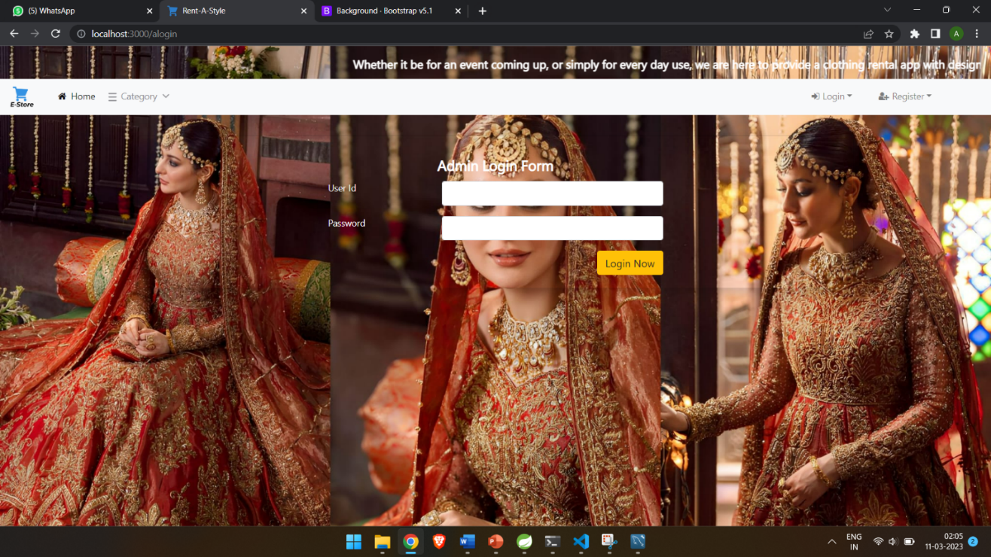Login
* 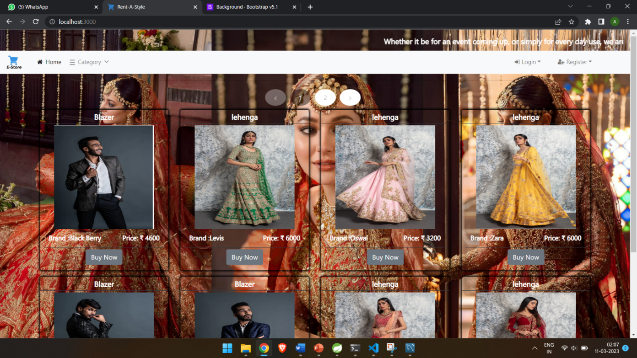Home Page
* Categories

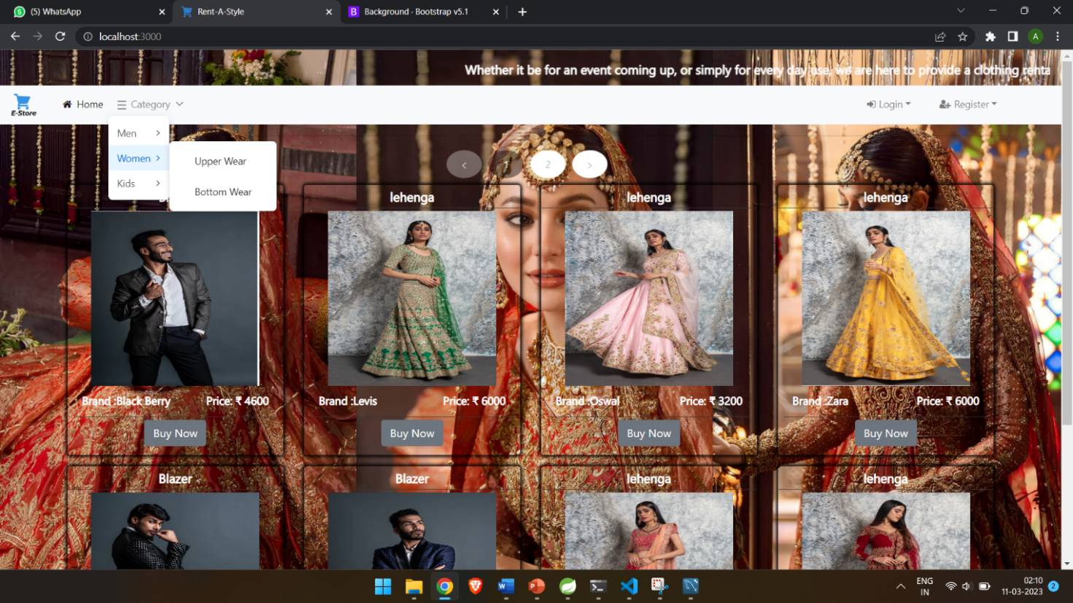

* 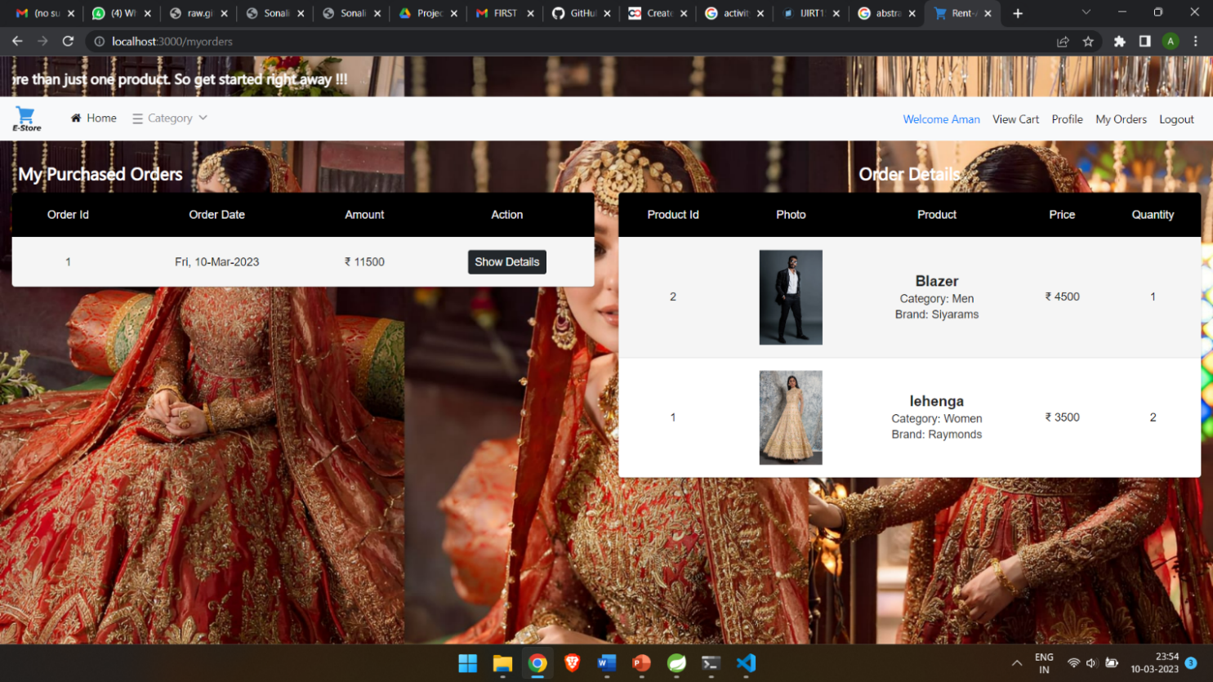Order Details
* Customer Profile

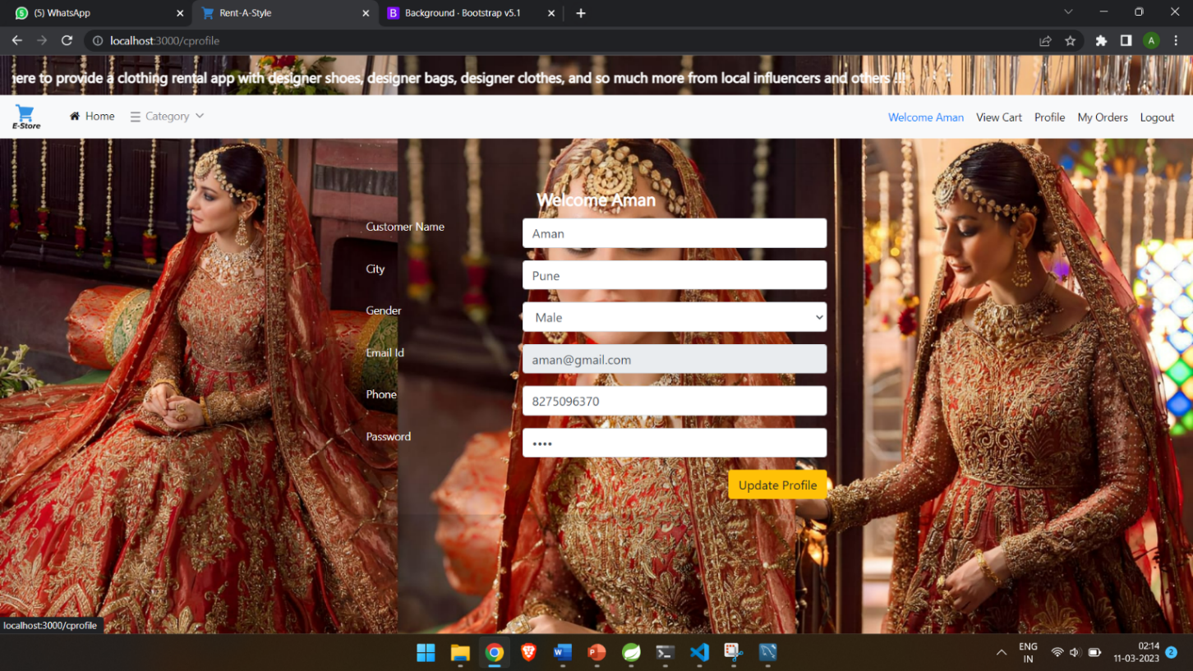

* 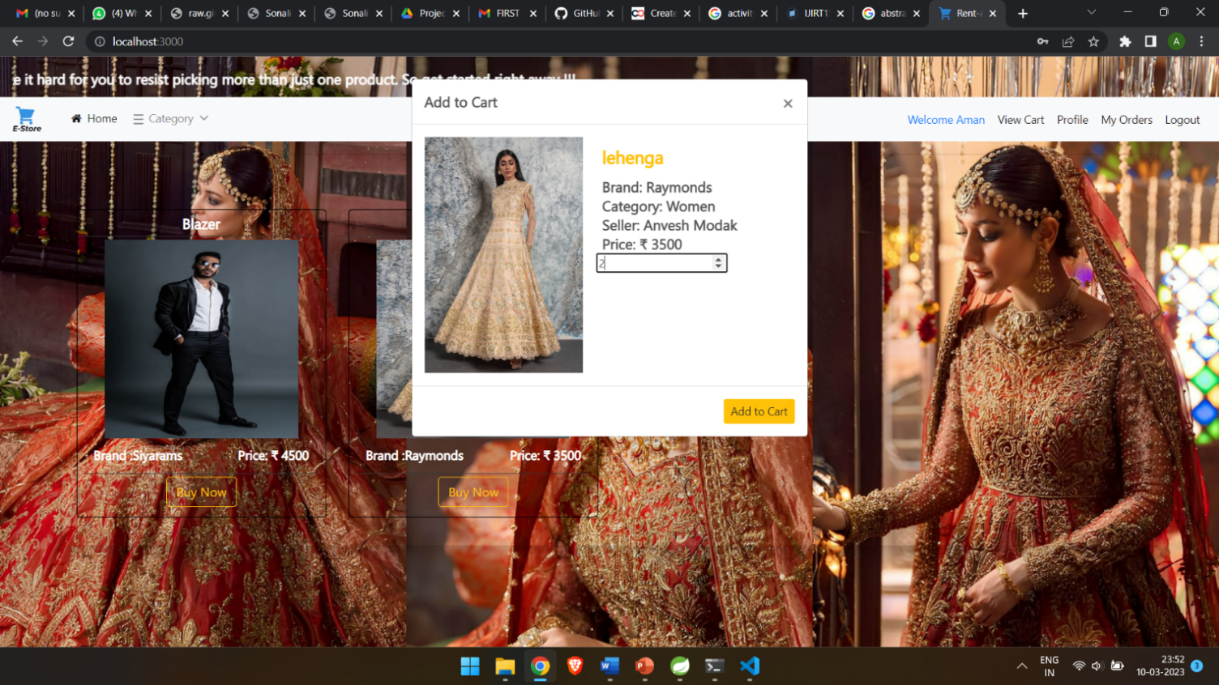Add to Cart
* Cart View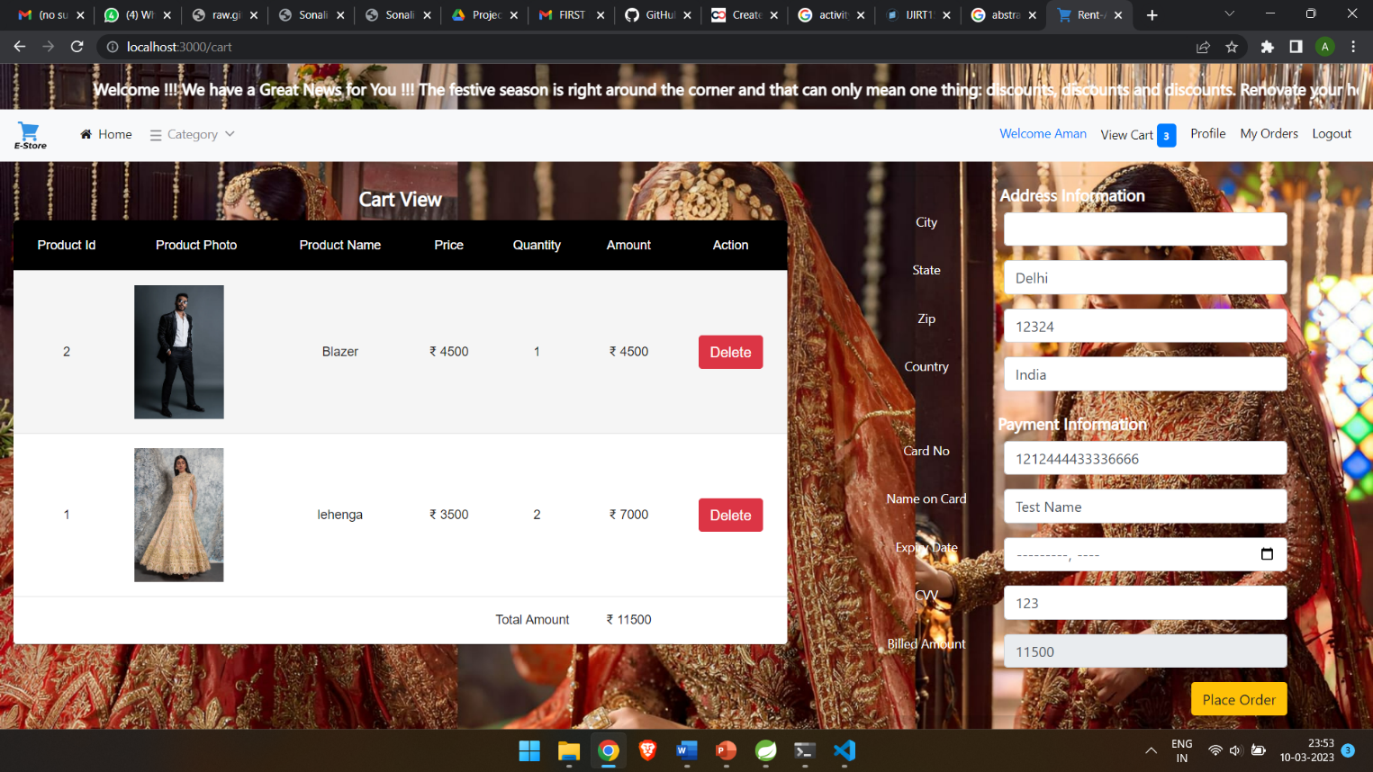

5.2.ADMIN

* 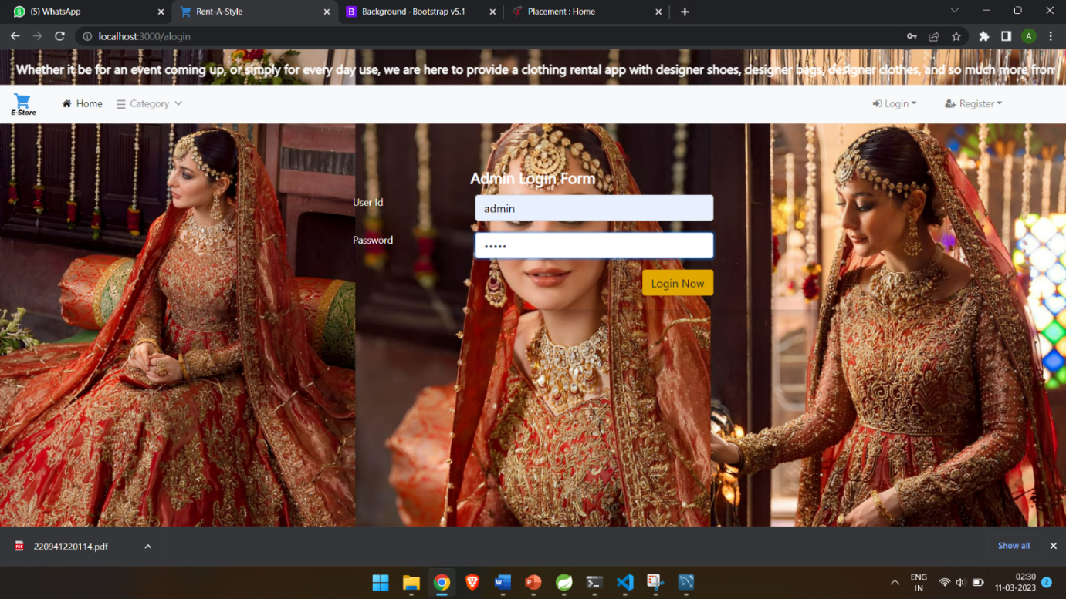Admin login
* 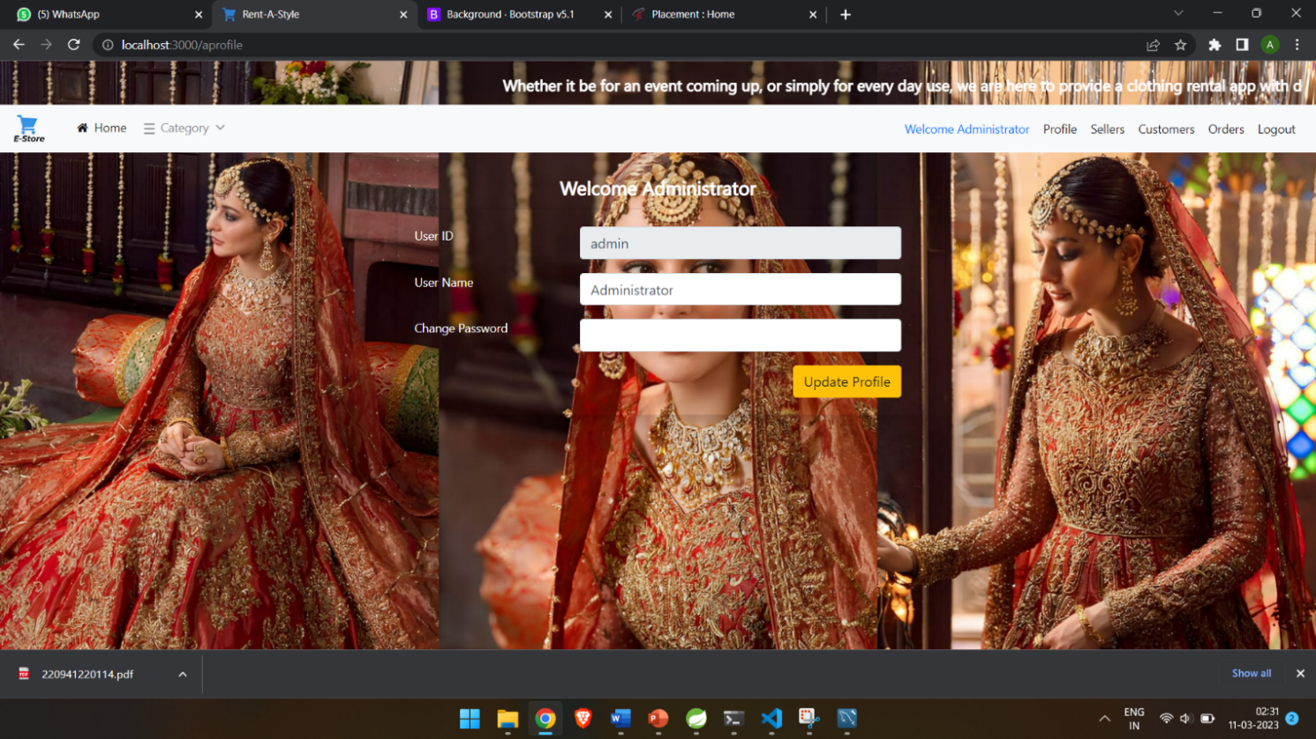Admin Profile
* 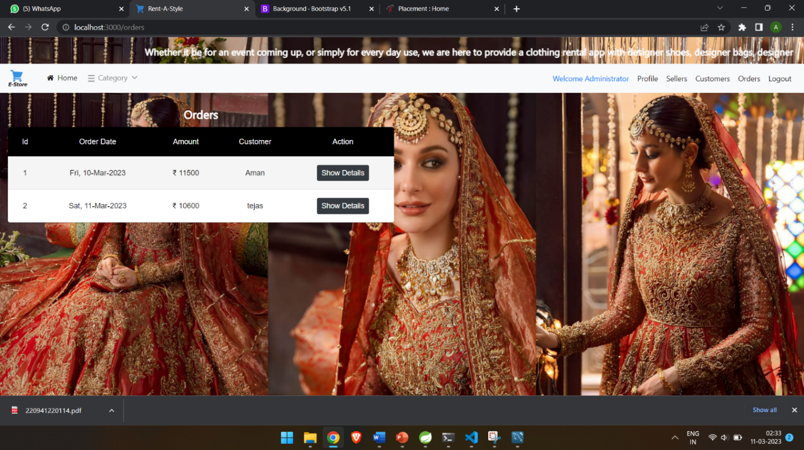Admin Viewing Order Details
* 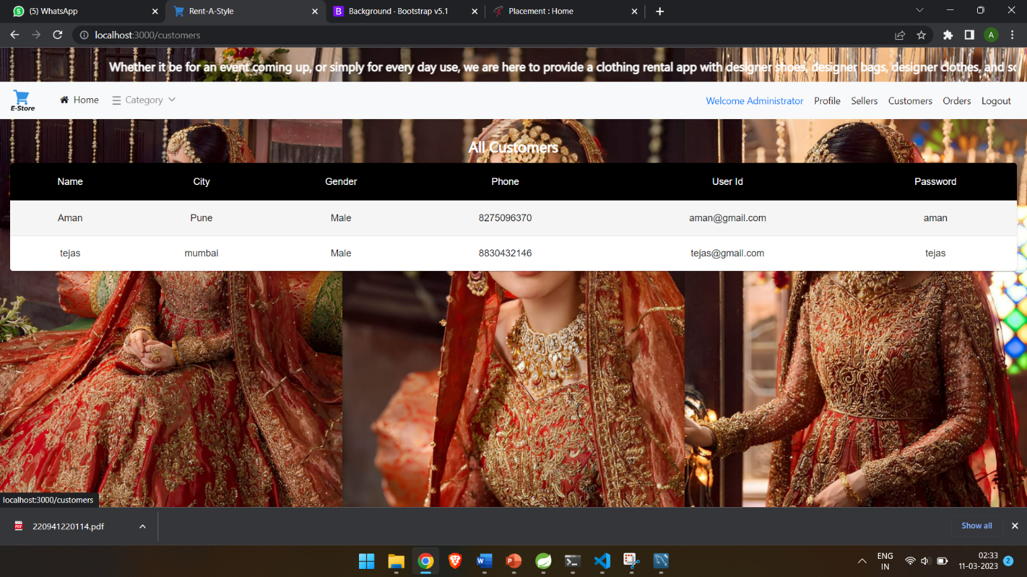Admin Customer Tab
* 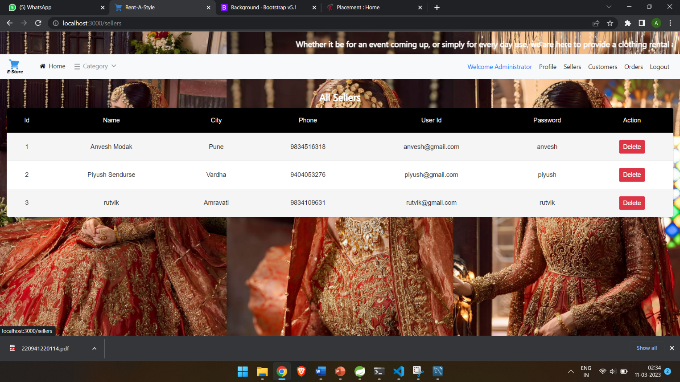Admin Seller Tab

5.3.SELLER

* Seller Login

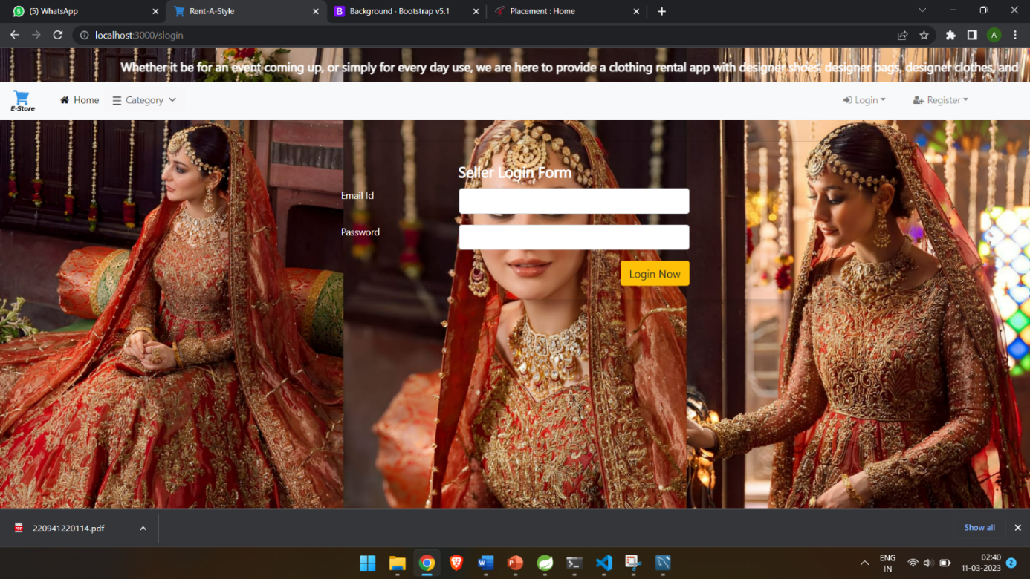

* 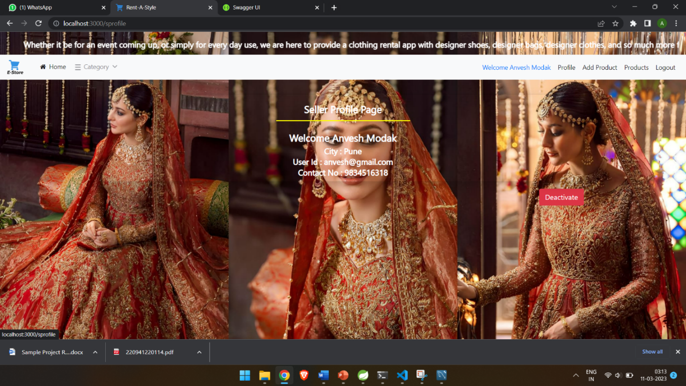Seller Profile
* 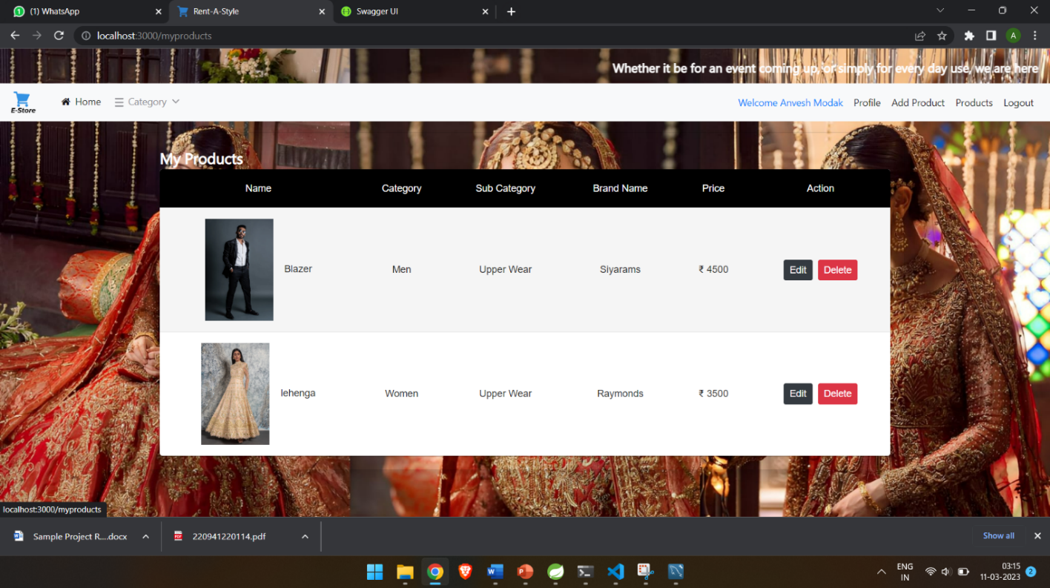Products List Seller
* 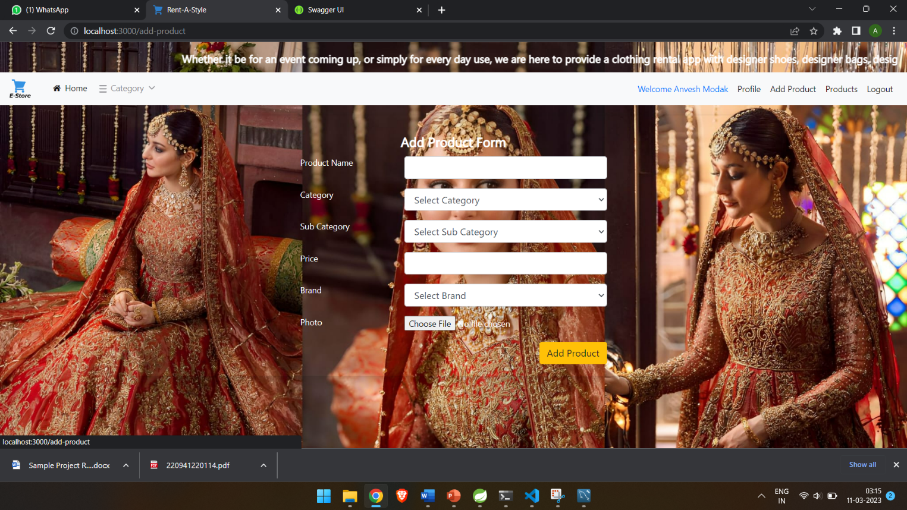Add Product Form
* Update Product Form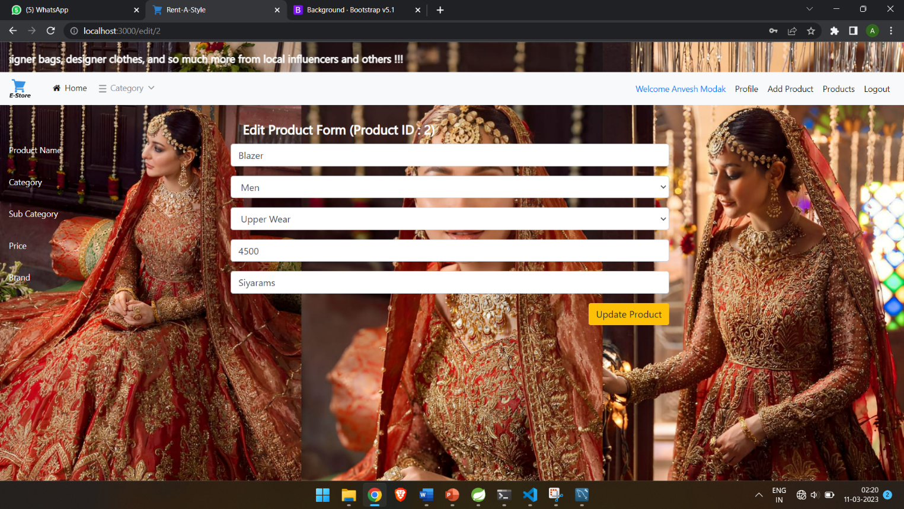
* 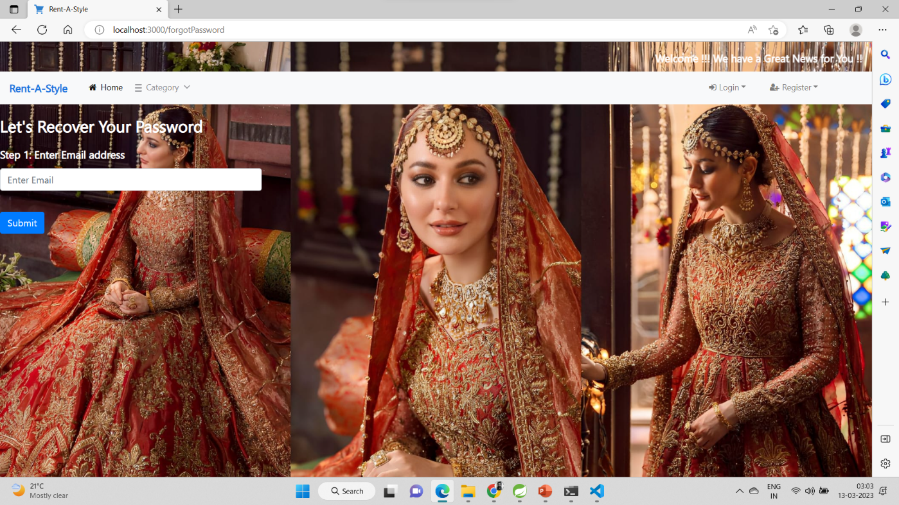Forgot Password

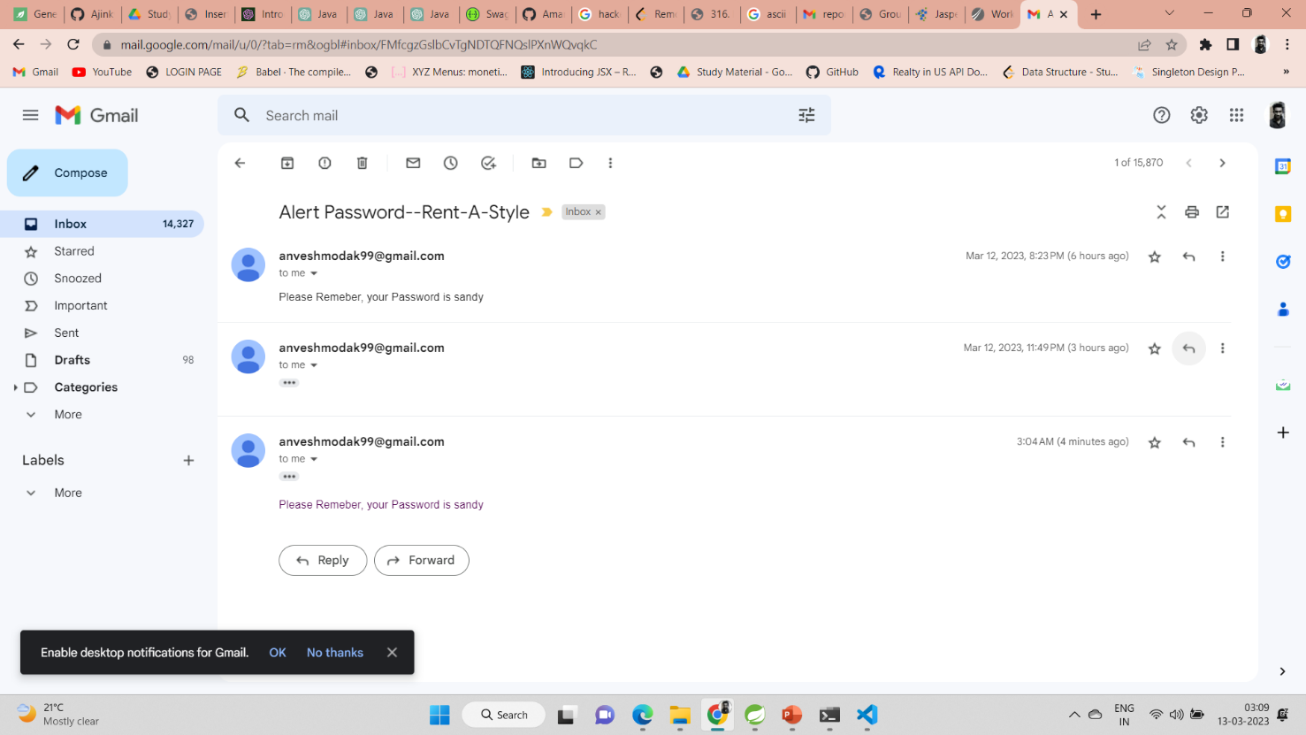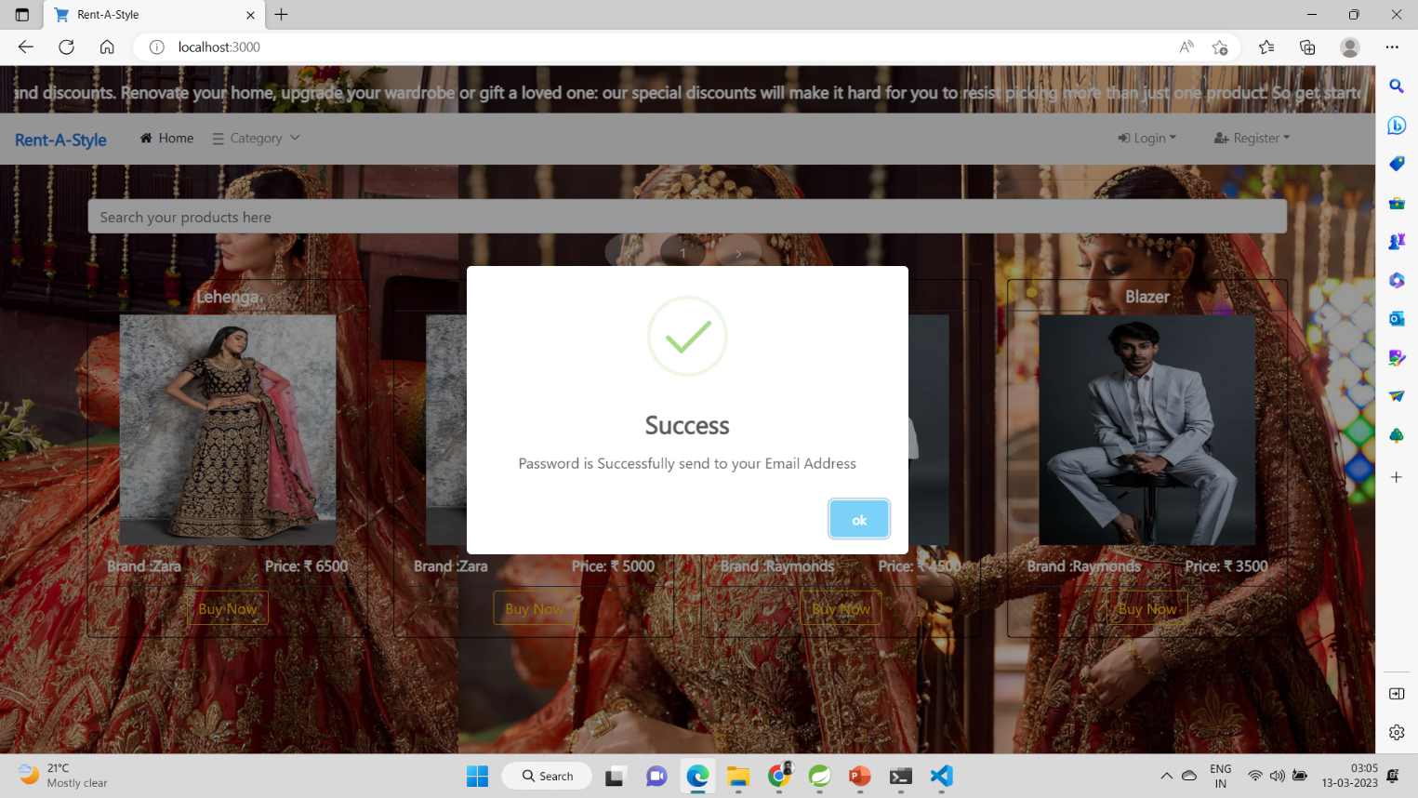

6. TESTING

One of the main purposes of testing is to validate and verify that the system works as intended. No program or system design is perfect. However, if we implement the system without proper testing, then it may cause problems and lead to a bad user experience.

Testing and checking outcomes of each test gives us the best chance to detect and correct errors before the system is implemented in a production environment.

In the course of our project, we made an effort to manually test each component. In all cases, we obtained the desired results as demonstrated below.



A. CUSTOMER FEATURES TEST

# Description Outcome Result

1. Register as Customer

|  |  |  |  |
| --- | --- | --- | --- |
| 1 | Register new customer | The details were saved in database. | Passed |

2. Login as Customer

|  |  |  |  |
| --- | --- | --- | --- |
| 1 | Login | Successfully fetched from database and authenticated | Passed |

3. Browse products

|  |  |  |  |
| --- | --- | --- | --- |
| 1 | Browse products | Successfully fetched the products from database | Passed |

4. Add product to Cart

|  |  |  |  |
| --- | --- | --- | --- |
| 1 | Add product to cart | The product was successfully added to the cart | Passed |

5. View Cart

|  |  |  |  |
| --- | --- | --- | --- |
| 1 | View Cart | The cart details were fetched from the database | Passed |

6. Place order

|  |  |  |  |
| --- | --- | --- | --- |
| 1 | Place order | The order was successfully placed. | Passed |

7.View Order History

|  |  |  |  |
| --- | --- | --- | --- |
| 1 | View Order | The orders were fetched from the database. | Passed |

8. Delete order

|  |  |  |  |
| --- | --- | --- | --- |
| 1 | Delete order | Order was successfully removed from the database | Passed |

9. Update customer profile

|  |  |  |  |
| --- | --- | --- | --- |
| 1 | Update profile | Customer details were successfully updated | Passed |

10. Logout

|  |  |  |  |
| --- | --- | --- | --- |
| 1 | Logout | The session was cleared. | Passed |



B. SELLER FEATURES TEST

# Description Outcome Result

1. Register as Seller

|  |  |  |  |
| --- | --- | --- | --- |
| 1 | Register new seller | The details were saved in database. | Passed |

2. Login as Seller

|  |  |  |  |
| --- | --- | --- | --- |
| 1 | Login | Successfully fetched from database and authenticated | Passed |

3. Add product

|  |  |  |  |
| --- | --- | --- | --- |
| 1 | Add product | The product was successfully added to the database | Passed |

4. Update product details

|  |  |  |  |
| --- | --- | --- | --- |
| 1 | Update product | Product details were successfully updated | Passed |

5. Logout

|  |  |  |  |
| --- | --- | --- | --- |
| 1 | Logout | The session was cleared. | Passed |

6. Deactivate Seller account

|  |  |  |  |
| --- | --- | --- | --- |
| 1 | Delete account | The account was deleted from the database. | Passed |

C. ADMIN FEATURES TEST

1. Login as Admin

|  |  |  |  |
| --- | --- | --- | --- |
| 1 | Login | Successfully fetched from database and authenticated | Passed |

2. Deactivate Seller and Customer account

|  |  |  |  |
| --- | --- | --- | --- |
| 1 | Delete account | The account was deleted from the database. | Passed |

3. View Order History

|  |  |  |  |
| --- | --- | --- | --- |
| 1 | View Order | The orders were fetched from the database. | Passed |

4. Update admin profile

|  |  |  |  |
| --- | --- | --- | --- |
| 1 | Update profile | Admin details were successfully updated | Passed |

5. Logout

|  |  |  |  |
| --- | --- | --- | --- |
| 1 | Logout | The session was cleared. | Passed |

7. CONCLUSION

“Rent-A-Style”, is an online shopping application, developed by our project team

to simplify the online sale and purchase of products. We tried using the latest technologies that are cross-platform and robust.

Each and every software we used was open-source in nature, which keeps the cost of production at a minimum.

We were also meticulous about the user experience aspect of our application so that navigating our website is an easy and seamless experience.

In conclusion, “Rent-A-Style” as an application would definitely be a good choice for any product trading business that wishes to enter the online market. We are confident that the numerous features and visually appealing look of the application will certainly give a big boost to the business.

.

8. FUTURE SCOPE

Using whatever we have learnt over the duration of this course, we tried to make our project as user-friendly and gave it as many features as possible in the limited time allotted for the project work. That said, there are certainly more features that can be added to our application. Some of those are mentioned below:

1. Product details can be viewed by hovering on the product.

2. Wish list can be implemented.

3. Customers can add reviews and feedbacks.

4. Additional payment means can be added other than cards.

5. After a confirmed purchase, an email with the invoice of the orders can be sent to the customer.

6. An order conformation notification/mail will be sent to the seller.

9. REFERENCES

Following is the list of websites we referred during the course of our project

1. <https://getbootstrap.com/docs/5.1/getting-started/introduction/>
2. https://reactjs.org/docs/getting-started.html
3. https://reactjs.org/docs/getting-started.html
4. https://www.baeldung.com/
5. https://www.w3schools.com/
6. <https://docs.spring.io/springdata/jpa/docs/current/reference/html/#reference>
7. <https://javadoc.io/doc/org.springframework.data/spring-datajpa/latest/index.html>
8. <https://developer.mozilla.org/en-US/>
9. <https://reactstrap.github.io/?path=/story/home-installation--page>
10. https://mui.com/material-ui/getting-started/overview/